**MUSTARD SEED NURSERY AND PRIMARY SCHHOOL**

**TERM ONE 2024**

**P.7 SCIENCE TOPICAL BREAKDOWN**

**THEME:** HUMAN BODY

**TOPIC:** MUSCULAR/ SKELETAL SYSTEM

**SUB TOPICS:**

* Structure of the human skeleton
* Names of different bones
* Joints
* Voluntary and involuntary muscles
* Function of the skeletal system
* Diseases and disorders of bones and muscles and the whole system
* Health habits that keep the system in healthy working conditions
* Prevention of the muscular and skeletal diseases
* Importance of correct posture.

**THEME:** MATTER AND ENERGY

**TOPICS:** ELECTRICITY AND MAGNETISM

**SUB TOPICS:**

**ELECTRICITY**

* Electricity
* Sources of electricity
* Types of electricity
* Conductors and insulators
* Electric circuits
* Short circuits
* Safety precautions in handling electricity and electrical appliances
* Importance of electricity in solving everyday life problems

**MAGNETISM**

* Magnetism
* Natural and artificial magnets
* Making temporary magnets
* Generating electricity using a dynamo
* Permanent magnets
* Uses of magnets and electric bell
* Electricity and magnetism in the modern world of work

**THEME:** THE ENVIRONMENT

**TOPIC:** ENERGY RESOURCES IN THE ENVIRONMENT

**SUB TOPICS:**

* Energy sources and their sources
* Energy resources from water ( hydro, steam, engines and tidal energy)
* Energy resources from fossil fuels
* Energy resources from plants ( bio fuels and bio gas )
* Energy resources from animals ( animal energy and biogas )
* Energy resources from wind
* Importance of other different energy resources

**WEEK ONE (LESSON ONE)**

**Topic 1: MUSCULAR – SKELETAL SYSTEM**

**VOCABULARY // New words.**

• **Skeleton Posture**

• **Hinge joint Ball and socket**

• **Pivot joint Gliding joint**

• **Voluntary muscles Involuntary muscles**

**Muscular – Skeletal System (lesson one)**

It is a system that gives animals the ability to move. It is a composition of bones and muscles

**A SKELETON**

It is the body part that forms the supporting structure of an organism.

**HUMAN SKELETON:** It is the frame work of bones in the body.

An adult human being has about 206 bones.

**TYPES OF SKELETONS.**

**1. Exo skeleton**. The hard material is formed on the outside part of the body.

Examples of organisms with exo skeleton are: insects and crustaceans. These animals grow by **ecdysis / moulting.**

**2. Endo skeleton**. The animals have bony skeletons within their bodies.

Examples of organisms with endo skeleton are: people, cow, etc.

**3. Hydrostatic skeleton**. This is where the pressure of the fluid and action of the surrounding muscles are used to change the shape of an organism and produce movement.

Examples of organisms with hydrostatic skeleton:

**snails**, **earth worms**, **slugs, star fish, jelly fish, sea urchins** etc.

**THE STRUCTURE OF HUMAN SKELTON**

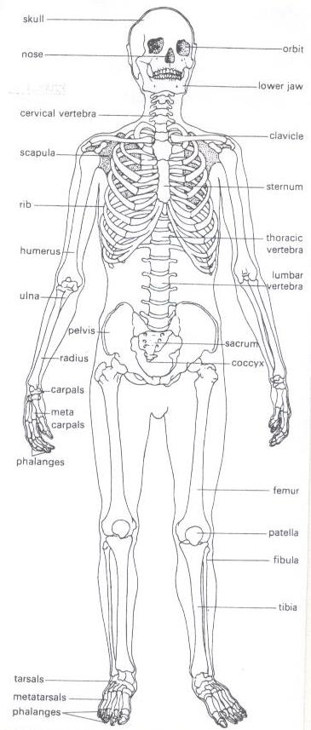

**Classifications of bones.(lesson two), WEEK TWO**

1. **Long bones**-e.g. **femur**, **tibia**, fibula, **humerus, radius, ulna**.

They contain the **white** bone marrow used to produce **white blood cells.**

2. **Short bones**- e.g. sternum, cranium, vertebra, ribs

They contain **red bone marrow** used to produce **red blood cells. Red blood cells** are **destroyed** in the **liver or spleen**.

3. **Flat bones** -e.g. **shoulder blade**, **cranium** [**(skull)**](http://en.wikipedia.org/wiki/Skull)[**, rib cage,**](http://en.wikipedia.org/wiki/Rib_cage) **and** [**scapula.**](http://en.wikipedia.org/wiki/Scapula)

4. **Irregular bones -**Bones of the neck **vertebr**a, sacrum.

**JOINTS(lesson three) WEEK TWO**

A joint is a place in a body where two or more bones meet.

**How is a joint adapted to a friction free movement?.**

-It contains synovial fluid which reduces friction at the joint.

-The bones are covered with cartilage at the ends.

**Structure of a joint.** 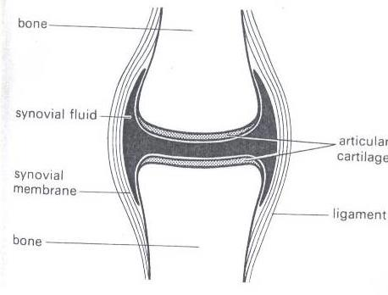

**A Tendon** is a tough fibrous tissue that connects muscles to bones.

**A Ligament** is a fibrous elastic tissue that joins a bone to a bone.

**Cartilage** prevents the bone ends frictional damage after rubbing directly onto each other. Inside a joint is **a lining of synovial membrane** which secretes **synovial fluid.**

**Synovial fluid** reduces **friction** in a joint.

**CLASSIFICATION OF JOINTS**

Joints may be either Movable, immovable or slightly movable

However, the principle types of joints are: Ball and socket joints, hinge joint, pivot joint, gliding joint.

**Examples of movable joints**

1.**Hinge joint**-It allows movement in one plane e.g. knee, elbow, knuckle

2.**Ball and socket**- It allows movement in three planes e.g. shoulder, hip

3.**Gliding joint-** They allow flat bones to slide over one another.eg wrist/ ankle

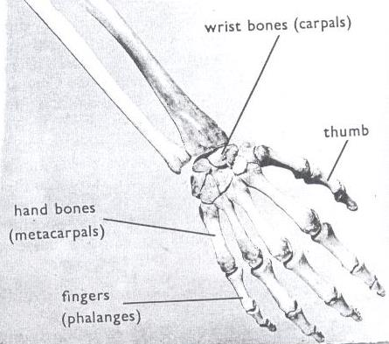

4.**Pivot joint**- e.g. the neck.

**Example of immovable joint**. Suture joints in the skull. **Questions**

1. How are joints important to a boy of 4 years?

2. What is a joint?

3. Write down one way joints are similar to muscles.

4. Write down any one example of a hinge joint.

5. Why is a shoulder joint said to be a movable joint?

6. State the substance in the human body that helps to reduce friction.

**Muscles (lesson five , week two)**

- A muscle is an elastic bundle of flesh under the skin that is attached to bones.

- A muscle is a special elastic tissue that contracts and relaxes to produce movement.

**There are two types of muscles.**

i. Voluntary muscles.

ii. Involuntary muscles.

**Voluntary muscles / skeletal muscles.**

Voluntary muscles are **muscles** whose action is normally controlled by an individual's will.

**Examples of voluntary muscles include;**

i. Biceps (flexor) ii.Triceps (extensor)

**Involuntary muscles smooth muscles.**

Involuntary muscles whose movement is not under our will. Examples of involuntary muscles;

**i.** Cardiac muscles of the heart.

**ii.** Muscles of the eye lids.

**iii.** Muscles of the stomach and intestines

**Antagonistic muscles**

These are muscles that work in pairs but have an opposite effect to each other.

Examples of antagonistic muscles include;

1. Biceps (flexor)
2. ii.Triceps (extensor

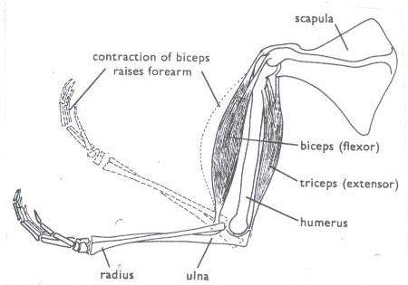

Questions

1.What is a muscle?

2.State the two types of muscles in our bodies.

3.Why the triceps and biceps are called antagonistic muscles?

4.How are muscles useful in our bodies?

5.Cite any one disorder to the body muscle.

**Functions of the muscular skeletal system.(lesson six)week two**

**1.** Protects the delicate body organs.

• The [**skull** prot](http://en.wikipedia.org/wiki/Human_skull)ects the [**brain,**](http://en.wikipedia.org/wiki/Human_brain)the [**eyes**,](http://en.wikipedia.org/wiki/Human_eye) and the [**middle** a](http://en.wikipedia.org/wiki/Middle_ear)nd [**inner ears.**](http://en.wikipedia.org/wiki/Inner_ear)

• The **vertebrae** (backbone) protect the [**spinal cord**.](http://en.wikipedia.org/wiki/Spinal_cord)

• The [**rib cage**, **s**](http://en.wikipedia.org/wiki/Human_rib_cage)**pine,** and  **[sternum](http://en.wikipedia.org/wiki/Human_sternum)** [prot](http://en.wikipedia.org/wiki/Human_sternum)ect the [**lungs,**](http://en.wikipedia.org/wiki/Human_lung)[**heart**.](http://en.wikipedia.org/wiki/Human_heart)

**2.** It provides supports to the body.

**3.** It helps in movement.

**4.** Storage of minerals like calcium and phosphorus.

**5.** The bone marrows are used to produce blood cells.

**6**. Provides room for attachment of muscles.

**Diseases and disorders of bones, muscles and the system(lesson seven)week two. Disorders of the muscular skeletal system.**

✓ Fractures

✓ Sprain

✓ Spinabifida -The spinal cord does not form properly.

✓ Cuts

✓ Strains

✓ Dislocation

**Diseases of the muscular skeletal system.**

✓ **Rickets-**causes bowed legs in children due to lack of Vitamin D.

✓ **Poliomyelitis**- Cause by polio virus which attacks the nerve cells and spinal cord causing paralysis.

✓ **Arthritis-**pain, stiffness and swelling of joints.

✓ **Scurvy**- caused by lack of ascorbic acid (vitamin C) in the diet.

**Prevention of diseases and disorders of bones, muscles.**

i. Boil water for drinking to prevent polio.

ii. Prepare and eat a balanced diet**.**

iii. Do physical exercises.

iv. Keep sharp cutting objects far from children’s reach.

v. Go for dental checkups *regularly.*

vi. Put on shoes while walking.

**Health habits that help to keep the system in a healthy working condition**

1. Do daily physical exercises.

2. Eat a balanced diet.

3. Ensure proper body posture.

4. Brush and floss your teeth twice a day.

**POSTURE.**

✓ It is a way a person positions his body when sitting, standing or walking

**The correct sitting Posture.**

✓ Sit up straight on the chair.

✓ Place both feet on the floor.

✓ Put all your weight on both bottoms.

✓ Do not tighten your ankles and knees.

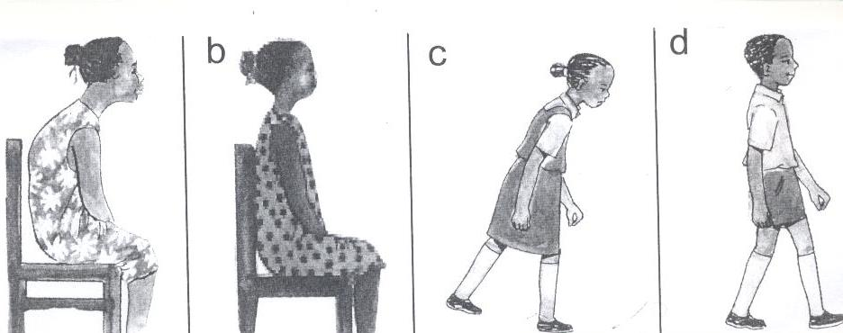

**Importance of correct posture**

I. Prevents body aches.

II. It prevents one from growing bent bones.

**Topical questions.**

1.Which class of food is necessary for proper growth of bones?

2. Write down one example of each

of the following a) Skeletal muscles b) Smooth muscles

3. What is the functional difference between ligaments and tendons?

4State one disorder to each of the following a) Ligaments b) tendons.

5. Which part of the skeleton protects the following?

a) Brain b) tendons

6. State one health habit that can keep one’s skeleton in a healthy working condition.

**Topic 2: ELECTRICITY AND MAGNETISM (lesson one) week two**

**VOCABULARY**

• **Electricity Fuse**

• **Circuit Switch**

• **Insulator Magnet**

• **Dynamo Electro – magnet**

• **Device**

**Electricity**

Electricity is a form of energy produced by the flow of electrons.

**Sources of electricity.**

-Cells i.e. Dry cell, Simple cell, chemical batteries, solar cell accumulators.

- Running water

-The sun.

-Fossil fuels.

-Wind.

**ELECTRIC CELLS** Types of cells

**1. Primary cells** e.g.), Dry cells, a simple cell(wet cell)

**2. Secondary cells/accumulators/storage cells.** E.g. lead batteries, solar cells.

**The dry cell.**

**Dry cell**

A dry cell is an electric cell. It stores chemical energy.

**Structure of a dry cell**

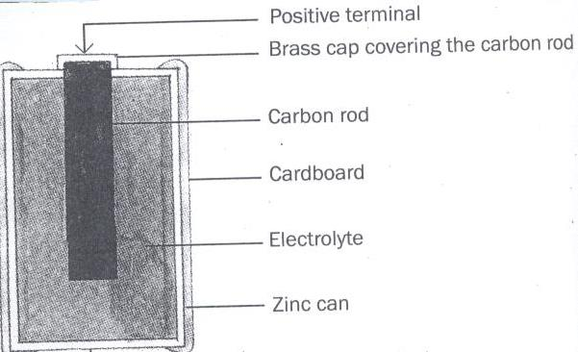

**Functions of each parts of a dry cell**

**1.Bras cap:** it acts as the positive terminal and contact.

**2.Carbon rod**: It is a non metallic conductor of electricity that acts as a positive pole.

**3.Electrolyte**: A liquid that conducts electricity.

**4.Zinc can**: a container in which the dry cell content is put and It acts as a negative terminal.

**5. Insulating top seal**: It prevents the jelly from drying up.

**N.B**: I. A dry cell has voltage of 1.5 volts

The energy needed to push an electric current through a electric circuit is called voltage.

Voltage is measured in volts.

A dry cell stores chemical energy which is later changed to electric energy.

**Calculating voltage. Exercise:**

1.Juliet’s radio uses **seven** dry cells.

How many volts are needed if he is to use it to listen to news. Solution:

**1 dry cell= 1.5 volts**

**7 dry cells= ?**

**7dry cells X 1.5 Volts.**

**=10.5 volts**

**2.How is the carbon rod useful in a dry cell?**

**3.Suggest any one cause of dry cells losing their energy.**

**4.What is the difference between electricity and electric energy/**

**5.Identify any one source of electricity.**

**Simple cell (Wet cell): lesson two, week two**

It consists of a zinc plate and a copper plate dipping in dilute sulphuric acid. The zinc plate acts as the **negative** pole.

The copper plate acts as the **positive** pole. Sulphuric acid acts as the **electrolyte**.

The zinc and copper are called **electrodes**

**An electrodes** is a piece of metal that allows electric current to pass through it when placed in an electrolyte

HOME MADE

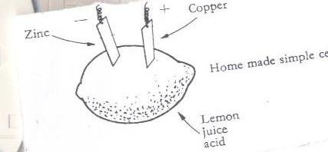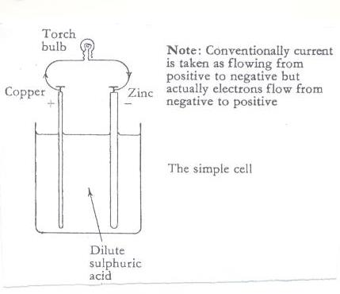

The bulb connected across the cell, begins to glow but after only a few minutes it becomes dimmer until it finally lights off.

**Disadvantages of using a wet cell.**

**i.** It is not very efficient.

ii.It can only be used in an upright position.

**ii.** It works for a short time

Questions.

1.What is the importance of the dilute sulphuric acid in a wet cell?

2.Why do wet cells lose their magnetism easily?

3. State one disadvantage of using wet cells?

4.What acts as the electrolyte in a locally made wet cell?

5.Why does a wet cell light for a shorter time?

**Chemical Battery( lesson three), week two.**

A Car battery is an example of chemical batteries.

It has the positive **(+) {anode}** and negative **(-)** terminals {cathode} called **electrodes**

Chemical batteries convert **chemical energy** into **electric energy.**

**Advantage of using a chemical battery.**

i.It can be recharged and used again when it has run down.

**Running water**

It produces hydro electricity {H.E.P}.

For example electricity produced at Nalubale AND Bujagali Dams in Jinja.

**The sun**

The sun produces light which is converted into solar electricity using solar cells. A number of solar cells put together form a solar battery.

Solar electricity is used for lighting and cooking

**Fossil Fuels.**

Fossil fuels used in production of electricity are coal, petrol and diesel.

**Coal / oil** can be burnt to produce Thermal electricity.

Coal stores chemical energy.

**Petrol and diesel** are used to run fuel generators.

**Uranium**

It is burnt to produce to produce nuclear energy. Uranium stores chemical energy.

**Wind**

The wind turns windmills to produce electricity. Questions

1.Cite any three sources of electricity.

2.How is the sun useful in the environment?

3.How is wind able to produce electricity?

4.Give one difference between wind and air

5.State any one example of a fossil fuel.

**Types of electricity.(lesson four)**

There are two main types of electricity;

1. Current electricity

**3.** Static electricity.

**Current electricity**

This is the electricity where there is flows of electrons.

**The diagram showing the flow of current/ electricity/ electric current.**

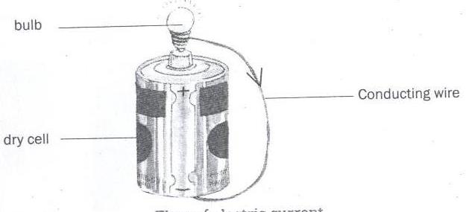

**The diagram showing the flow of electrons**

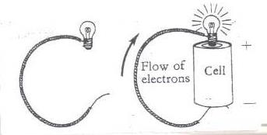

**Types of current electricity.**

**1.Direct current (DC) -** The current flows in one direction. I e from the source to the appliance.

**Sources**: chemical batteries and dry cells.

**2.Alternating Current (AC) -** current flows in two directions. I e from the source to the appliance and the back.E.g. that one produced at **Nalubale dam in Jinja, generator**

**Forms of electricity.**

**a) Hydro electricity**; produced from water turning turbines at a dam.

**b) Thermal electricity;** Produced from fossil fuels.

**c) Solar electricity;** Produced from the sun.

**d) Nuclear electricity;** Produced from nuclear power stations**.**

**e) Geo thermal electricity;** Produced from hot rock in the earth.

**QUESTION**

**1. Write down the types of electricity**

**2. State any two forms of electricity**

**3. Draw a diagram to show flow of electricity**

**4. What type of electricity is commonly used by most urban areas in Uganda?**

**5. Briefly explain the term alternating current.**

**Conductors of electricity**

**( lesson four , week two)**

Conductors are materials that allow electricity to pass through them .

**Examples of conductors of electricity.**

1. Metals like; Iron, copper, Tin, Silver, zinc, lead, brass.

ii. Materials like; spoons, pair of compasses, razor blades e.t.c.

iii. Water from rivers, lakes, springs and wells.

1. Carbon {nonmetallic conductor)
2. Salt solution
3. Wet wood

**NB**

1. Wet wood is a good conductor of electricity because it contains minerals.

2. Pure water does not conduct electricity because it doesn’t contain minerals.

**3. Silver** is the best conductor of electricity.

4. We use aluminum to make electric wires because silver is expensive and rare.

**Insulators of electricity.**

These are materials that do not allow electricity to pass through them easily.

**Examples of insulators;**

**i.** Rubber, plastic, dry wood, dry paper, dry cloth, air and porcelain

**Importance of insulators**

1. Used to insulate flat irons to prevent electric shocks.

2. Prevent conductors from meeting to cause short circuits.

**Electric circuit (lesson five)**

An electric circuit is a path through which an electric current flows.

**Components of an electric circuit.**

➢ A switch.

➢ A torch bulb

➢ A conductor (wire)

➢ Dry cells

➢ The conducting wire.

➢ Fuse

Questions.

1. How are insulators different from conductors of heat?

2. Give any two examples of insulators.

3. How are insulators important in our daily life?

4. State any two components of an electric circuit.

5. Why is wood said to be bad conductor of electricity?

**A simple Electric circuit. (lesson five week two)**

**In symbol form In diagram form**

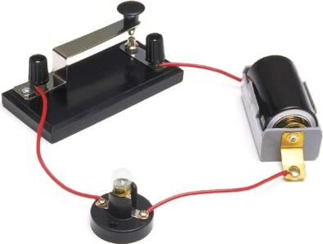

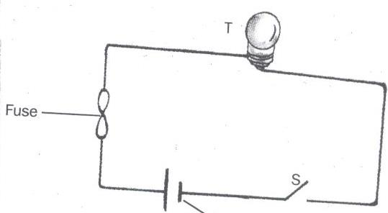

**Uses of parts of an electric circuit.**

**1. Switch**: This breaks and completes the circuit at the users wish.

**2. Battery/dry cells**: These provide electric energy in the circuit.

**3. Conducting wire**: Transmits electric energy through the circuit.

**4. Fuse**: It breaks the circuit when there is too much current flowing. It is a thin wire with a low melting point.

**5. Bulb:** It gives out light.

**Symbols used in an electric circuit.**

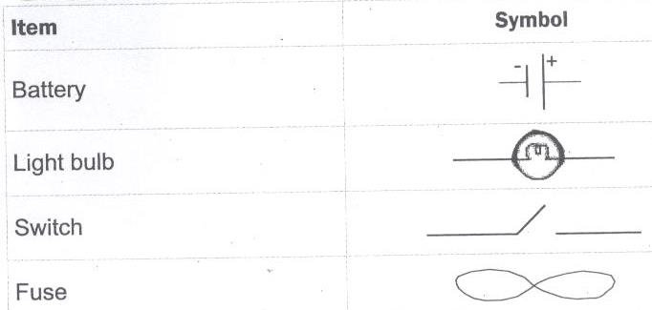

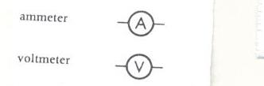

**The conducting wire**

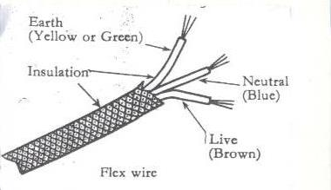

**Uses of each component of a conducting wire**

i. **Earth (yellow or green):** Minimizes excess current to prevent us from electric shocks. ii. **Neutral (Blue/black):** Takes back current to the source.

iii. **Live (Red/brown):** brings current from the source to the appliance.

iv. **Insulation**: prevent electric shocks.

Questions

1. How are the following important in a circuit?

a) Switch

b) Fuse

2. How is a fuse similar to a switch?

3. How is a red wire useful in an electric circuit?

4. Draw a diagram of a bulb.

**The torch/flash light (lesson six), week two**

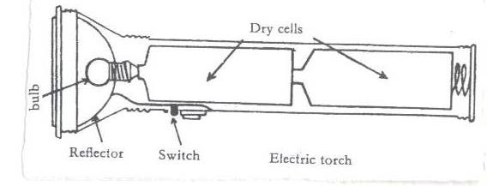

**Uses of parts of a torch**

**1. Reflector**: Directs lights into **a parallel** beam of light.

**2. Bulb**: It produces light.

It changes electric energy to heat then to light.

**3. Dry cells**: It is the source of electric energy.

**4. Glass**: It protects the bulb and reflector.

**5. Switch**: Breaks and completes the circuit at the users wish.

**6. Cover and springs**: Keep the dry cells tightly together.

**The Electric Bulb. (lesson seven) week two**

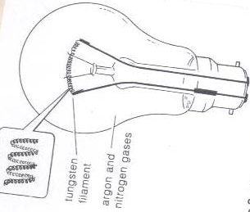

**Uses of parts of a bulb**

**1. Filament:** It produces light.

It is made of **tungsten** from a mineral called **wolfram**

**Adaptation of the filament for its function.**

✓ It has a high melting point.

✓ It is coiled to increase electric resistance

**2. Conducting wire**: It conducts electricity to the filament.

**3. Glass**: Protects the inside parts of the bulb.

It prevents nitrogen and argon gases from escaping. It is transparent to allow light to pass through.

**4. Filament support**: It supports the filament.

**5. Contact**: It allows electricity into the bulb.

**6. Insulating material**: It separates the conducting wires.

**Question**

1.Why is a filament of an electric bulb coiled?

2.State any component of a circuit that use an alloy.

3.How is the reflector important in an electric torch?

4.Which gas is commonly used in electric bulbs?

5.Give one reason why the glass of a bulb is transparent?

**Short circuits.(lesson eight) week two.**

A short circuit is a path of low resistance towards flow of current through circuit.

**Causes of short circuit**

✓ Poor wiring when installing electricity in buildings.

✓ Pushing metallic objects in electric sockets.

✓ When bare electric wires get into contact.

✓ Wrong connection of wires in electric equipment.

✓ Overloading sockets.

**Effects of short circuit.**

➢ Destruction of electrical equipment.

➢ Fire that may burn the building.

➢ Lead to death of people and animals.

**How to avoid short circuit**

➢ Electric wires should be covered with an insulating material.

➢ Installation should be done by experts only.

➢ Repair of electric appliances should be done by experts.

**STATIC ELECTRICITY (lesson 9) week two**

➢ It is the type of electricity where there is no flow of electrons.

➢ It is formed when two insulators are rubbed against each other.

➢ In nature static electricity can be seen when lightning occurs.

**Lightning.**

➢ This is static electricity in nature.

➢ When a positively charged cloud meets a negatively charged cloud, a huge spark is formed and may pass to the ground.

➢ During the passage of lightning, the surrounding air is heated strongly, expands suddenly and then

contracts quickly as it cools.

➢ This air vibrates to produce the sound called **thunder.**

**Advantage of lightning**.

➢ Lightning fixes nitrogen into the soil.

**Preventing effects caused by lightning.**

➢ Avoid sitting under tall trees when it is raining.

➢ Install lightning conductors on buildings.

**How lightning conductors reduce risks to the building.**

➢ They provide route for electrons to pass into the ground without damaging the building.

**Differences between static electricity and current electricity**

|  |  |  |
| --- | --- | --- |
|  | **Static** | **Current** |
| 1 | Takes place in insulators. | Takes place in conductors. |
| **2** | The charge is on the surface. | Charge is inside the conductor. |
| 3 | The charge does not flow. | Charge flows through the conductor from one place  to another. |
| 4 | Protons (+) and electrons (-) are both necessary for this type of electricity. | Only electrons flow. |

**Importance of electricity**.(lesson ten), week two.

➢ Cooking

➢ Lighting

➢ Run machines like radios,

**Advantages of electricity in solving everyday problems.**

➢ It is quick.

➢ It is clean.

➢ Easy to use.

➢ Conserves the environment.

**Disadvantages of electricity**.

➢ It is expensive to install.

➢ Electricity can shock.

➢ It can burn buildings.

**Safety precautions in handling electricity and electrical appliances.**

➢ Never touch a switch with wet hands

➢ Avoid over loading the socket.

➢ Avoid repairing the appliance when not trained.

➢ Avoid pushing metallic objects into sockets.

➢ Never open anything that uses electricity if not an expert.

➢ Never touch an electric wire that has fallen from an electric pole.

➢ Never take shelter under tall trees during thunderstorm.

**Topical questions**

1. Briefly explain the term electricity.

2. Why electricity is called a form of energy?

3. Give any one way in which electricity can prevent deforestation.

4. Why is it important to properly handle electric appliances?

5. Draw a symbol of an electric bulb.

6. Suggest any one way in which we can prevent our electric appliances from being destroyed by electricity.

7. State any one difference between conductors and insulators.

8. Why are electric wires carrying current from the source raised some meters high from the ground?

9. Cite any one disadvantage of using electricity in the environment

10. Draw a diagram to show the flow of current.

11. Cite any one danger of lightning to the environment.

12. State the static electricity in nature.

13. Briefly explain how to overcome the dangers of caused by short circuits in the environment.

14. Why is the filament of an electric bulb coiled?

15. How is a fuse important in an electric circuit?

**Magnetism (lesson one), week three**

Is the property of a magnet which enables it to attract or repel other metals.

**Magnet**

Is a piece of metal that attracts other magnetic substances.

**What are magnetic materials?**

Are materials that can be attracted by a magnet. They can easily be magnetized.

**Examples of magnetic materials**

➢ Iron (most common magnetic substances)

➢ Nickel

➢ Cobalt

➢  **What are non magnetic substances?**

Are substances that cannot be attracted by magnets.

**Examples of non magnetic substances**.

➢ Dry wood

➢ Plastic

➢ Lead

➢ Glass

➢ Cloth

➢ Copper

➢ Paper

➢ Aluminium

➢ Brass

**Types of magnets.**

There are two main types of magnets;

i**. Artificial magnets. ii. Natural magnets.**

1. **Artificial magnets ( lesson two )week three**

These are magnets made by people.

**Examples of artificial magnets and their shapes.**

➢ **Bar magnet**; This is a bar of uniform cross section. It may be rectangular or circular.

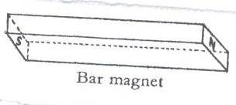

➢ **Horse shoe magnet**; It has u shape.

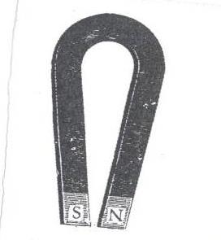

➢ **Needle magnet**; It has a thin pointed at both ends and balanced at the centre.

➢ **Electromagnet**

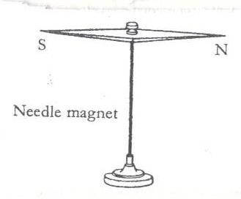

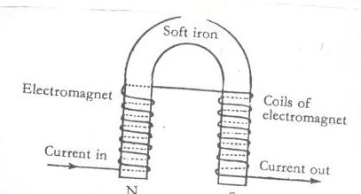

**b) Natural magnets**

They don’t lose magnetism.

**Examples of natural magnets.**

➢ **The Earth**; It is a huge natural magnet. Its magnetic field is weak, that is why you can’t feel it.

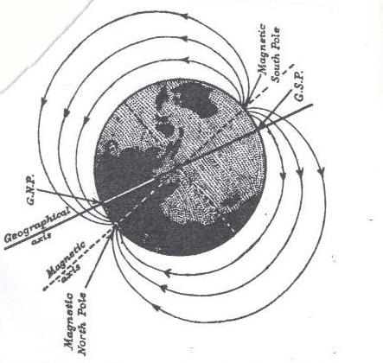

➢ **Lodestone/magnetite**; Lodestone is a magnetic ore which occurs naturally in the earth. It was discovered near the ancient city of magnesia in Asia Minor. It was the first magnet to be discovered by people.

**Properties of magnets(lesson four week three.**

➢ Like poles of a magnet repel.

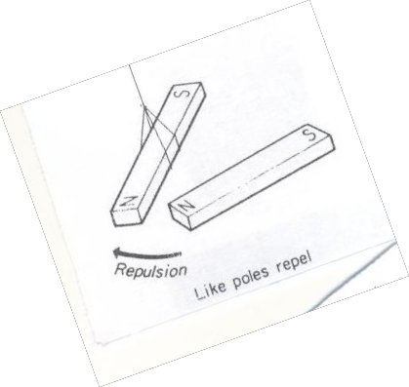

➢ Unlike poles attract each other.

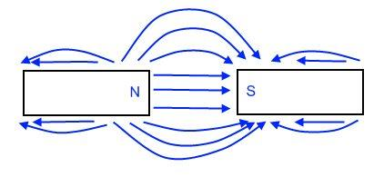

➢ When a magnet is freely suspended by a piece of thread it will always rest in the north –south direction.

➢ The poles are the strongest part of the magnet.

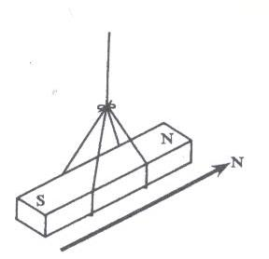

➢ Magnets have magnetic fields around them.

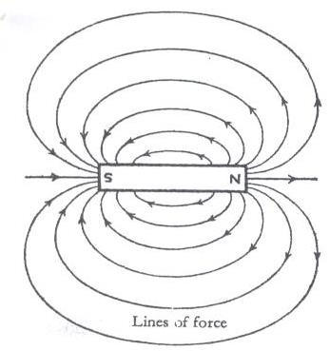

➢ Magnetism passes through **non magnetic materials** like wood and paper.

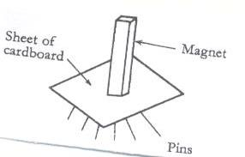

➢ Broken pieces of magnets regain their poles.

➢ Magnets become weaker with age.

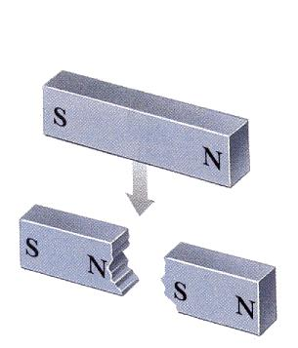

**Preventing magnets from losing magnetism.**

➢ Keep them using iron keepers.

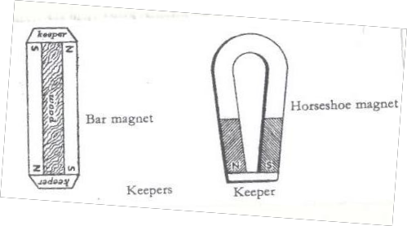

(Lesson four) week three

**Laws of magnets**

➢ Like poles of a magnet repel each other while unlike poles attract each other.

**What is magnetic field?**

It is the area around the magnet in which it can attract other magnetic materials.

**Properties of magnetic fields.**

❖ They originate from **North Pole** and end at the **South Pole.**

❖ The lines forces do not intersect with each other.

❖ A line of force is continuous; it starts from the North Pole and ends at the south pole.

❖ There is no line of force within the magnet itself

**Methods of making magnets**.

➢ **Stroking by single touch:**

It is stroking by single touch method because one magnet is used.

Note. **The end after the stroke becomes the opposite pole of the magnet being used.**

**Stroking by double/divided touch**

It is so because two magnets are used.

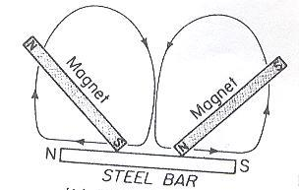

➢ **By induction** A magnetic object becomes magnetized by induction when it is nearer or contact with a magnet.

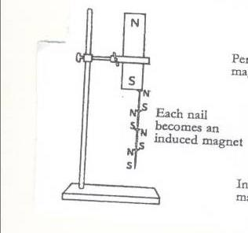

Lesson five and six ) week three

➢ **By electrical method**

This is a method of making magnets using electricity

A magnet made by using electricity is **electro- magnet.**

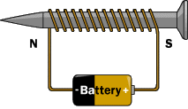

**Electro magnets are made stronger by;**

➢ By increasing the coils around the soft iron

➢ By increasing the voltage (electrical strength

**Determining the poles an electromagnet. i. The direction of flow of current.**

• Looking at it from either end;

➢ If current flows in an **anticlockwise** way through the solenoid, the pole is **North (N)**

➢ If current flows in **a clockwise** way through the solenoid, the pole is **South(S).**

**ii. Using the right hand grip rule.**

❖ Grasp the solenoid in the **right hand** with **thumb pointing in the direction of current.**

❖ The thumb points to **the North Pole.**

**Demagnetizing a magnet(lesson seven) week three**

• It is making a magnet lose its magnetism.

• It is weakening or destroying a magnet.

**Ways of demagnetizing a magnet**

• Hammering/hitting strongly.

• Strong heating.

• Leaving a magnet in an east-west direction for a very long time.

• By keeping the magnets with like poles together.

• By passing an **alternating current** through a magnet.

• Leaving it to rust.

➢  **Uses of magnets in modern world of work.**

➢ Magnets are used in compasses by sailors, pilots and explorers.

➢ Electromagnets are used in industries to collect heavy scrap iron.

➢ An electric bell is also built on the principle of magnets.

➢ Magnets are used in telecommunication devices.

➢ Electric motors which produce electricity use magnets.

➢ They are used in loud speakers.

➢ They are used on doors of fridges.

**Appliances that use electricity**

➢ Flat irons

➢ Heaters

➢ Driers.

➢ Washing machines

➢ Electric fans

➢ Cooker

**Appliances that use magnetism**

➢ Magnetic compasses.

➢ Magnetic tapes.

**Appliances that use both electricity and magnetism.**.

➢ Fridges.

➢ Radios

➢ Televisions

➢ Mobile phones

➢ Electric bells

**An Electric bell(lesson eight and nine) week three**

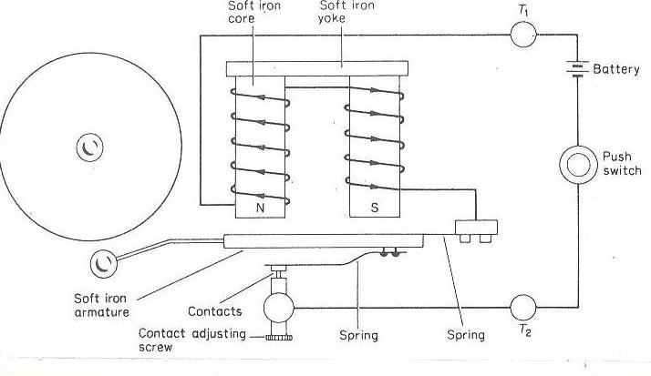

**How it works**

❖ When the contact is made the soft iron becomes magnetized.

❖ It pulls the soft iron strip with the hammer.

❖ The hammer hits the gong producing sound.

❖ When the strip is pulled the soft iron loses its magnetism and the contact is broken because current is not flowing.

**Generating electricity using a dynamo.**

**Dynamo.**

A dynamo is a device which converts mechanical energy into electrical energy. A dynamo uses **a permanent magnet** and a coil of wires on electro magnets During the turning, the **mechanical energy** is turned into **electric energy.**

**Generator**

The type of current electricity produced is **A.C**

They change **Mechanical energy** to **electric energy.**

**Uses of dynamos and generators**

➢ Provide electricity for light.

➢ Provide energy to run machines.

➢ Provide energy for cooking

➢ Generators are used in hospital theatres incase power goes out.

**Topical questions**

1. How is magnetism different from magnets?

2. State the any one law of magnetism

3. How are magnets important to the following?

a) Doctors

b) pilots

c) teachers

4. Cite one item that uses both magnets and electricity.

5. How are magnets found in radios important?

6. In four sentences, briefly explain how an electric bell works.

7. Write the term AC in full.

8. What is the importance of the hammer found on an electro magnet?

9. State one way of making magnets.

10. In which one way can a p7 child make a magnet lose its magnetism?

11. Briefly explain how strong heating a magnet can make it lose its magnetism?

LESSON ONE WEEK FOUR

**TOPIC 3: ENERGY RESOURCES IN THE ENVIRONMENT.**

**VOCABULARY**

• **Resource Hydro**

• **Tidal Fossil**

• **Coal Petroleum**

• **Bio gas Bio fuel**

• **Wood fuel**

**A RESOURCE**

This is anything that people uses to satisfy their needs.

**ENERGY RESOURCE**

It is anything that provides people with useful energy.

**TYPES OF RESOURCES.**

1. Renewable resources. – Things that can be replaced naturally when used up.

**Examples:** Plants, animals, land( soil), water, air,

2. Non renewable resources.- Things that cannot be replaced when used up.

Examples: Minerals, rocks, fossil fuels.

**Energy resources .**

-Sun, Water, Minerals, Air or wind, Plants and Animals.

**The sun as major source of energy in the environment (solar energy).**

**THE SUN**

The sun is the main source of heat and light as forms of energy on earth.

**Importance of the sun to people and environment**

➢ The sun helps in rain formation.

➢ Preserve our food by sun drying.

➢ Helps the human skin to make vitamin D

➢ Helps to disinfect beddings

➢ Light from the sun helps us to see.

➢ Light from the sun is used to make solar electricity.

➢ Light from the sun enables plants to make food.

➢ Dry our clothes.

**Water as an Energy resource:**

It helps people to get the following form of energy.

➢  **Hydro electricity:**

It is the form of electricity produced by the power of running water at a fall.

When waterfalls at a greater height, **potential energy** is changed to **kinetic energy**.

**Kinetic energy** turns the turbines connected to a generator with powerful magnetic field and a coil of wire turning it. In this way HEP is produced.

➢  **Steam**

Steam with Kinetic energy helps to power **steam engines.**

LESSON TWO WEEK FOUR

➢  **Tidal energy**

This is the form of energy got from **water tides** on the sea shores. Tides are periodic rises and falls of large bodies of water.

The tides are caused by gravitational interaction between the earth and the moon.

**Importance of water as an energy resource to people and environment**

➢ Fast running water at a fall turns turbines to produce HEP.

➢ Used to cool machines in industries.

➢ Used for bathing and drinking.

➢ Tidal energy is used to produce electricity.

**Fossil fuels (coal, petroleum, Uranium) as energy resources. Importance**

**Examples of fossils.**

➢ Coal

➢ Petroleum

Petroleum//crude oil

It is an energy resource from the ground formed from animals that died many years ago.

The changes in the earth created a lot of heat and pressure on them hence turning into petroleum.

Examples of petroleum.

➢ Petrol, diesel, oil, jet fuel, paraffin

These fuels are got from crude oil by the process called fractional distillation.

**Importance of petroleum products**

➢ Used to generate power that can run machines and vehicles.

➢ They are burnt to produce light and heat.

**Importance of coal.**

➢Used as fuel in steam engines.

➢ Coal is burnt to produce thermal electricity

➢ It is used to make tar for surfacing roads.

**Other products from petroleum.**

➢ Plastics, polythene paper, tar, dye, detergents, Vaseline, mattresses, grease, paint, fertilizers, etc

**Other products from coal**

➢ Paints, fertilizers, perfumes.

Uses of uranium

➢ It is used to make atomic bombs.

➢ It is used as fuel in nuclear powered sub marines.

➢ Uranium is burnt to produce atomic electricity.

Geothermal energy

➢ It is got from hot springs// thermal springs where steam is trapped to turn turbines to produce electricity.

**ANIMALS AS ENERGY RESOURCES.**

➢ Animals like oxen are used to plough land.

➢ Some animals like the donkeys are used for transport.

➢ Some animals are used as source of food.

➢ Some animals like oxen and ass are used to pull carts.

PLANTS AS ENERGY RESOURCES.

➢ They are source of food.

➢ They are source of wood fuel.

➢ They are source of building materials.

➢ They are used as shelter by some animals.

**How to conserve plant resources.**

➢ Through a forestation.

➢ Use fuel saving stoves.

➢ Use other //alternative sources of fuel like biogas.

➢ Educate people about the advantages of plants in the environment.

**Wind as energy resources. AIR/WIND**

Importance.

➢ Used for winnowing

➢ Used to turn wind mills to produce electricity.

➢ Used to sail boats

➢ Helps to disperse seeds

➢ Used in pollination.

➢ Used to fly kites.

➢ Speed up evaporation and hence increases the speed to dry things.

**Plants (wood fuel, food) as energy resources.**

LESSON FIVE AND SIX WEEK FOUR

**Animals as energy resources.**

**Biogas production from plants**

**What is biogas?**

It is a methane that is produced from the rotting organic matter.

The waste plant materials.

Cow dung.

2. Plant materials.

3. Animal urine.

**Steps of making biogas digester.**

The above materials are put into an air-tight container called a biogas digester. where they are worked on by anaerobic bacteria to ferment and biogas is formed. When the gas formation stops, the remains can be used as manure.

**Structure of Biogas digester**

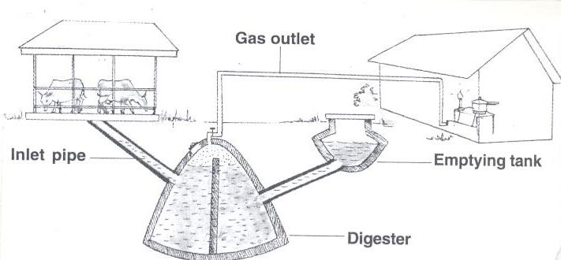

**Uses of the parts**.

➢ Inlet: For inserting in plant and animal matter.

➢ Inlet pipe: allows plant and animal matter into the digester.

➢ Outlet: For removing old used up matter to the garden.

➢ Emptying tank:Where used up matter is collected before it is taken to the garden.

➢ Biogas tube: It traps biogas and takes it to the heating or lighting equipment.

**Uses of biogas**

1. For cooking

2. For lighting

3. For heating.

**Advantages of using biogas**

1. It is cheaper than using natural gas

2. It does not pollute the environment.

3. The materials are readily available in the environment.

**TOPICAL QUESTIONS**

1. In which one way do plants depend on?

a) Cattle b) human beings c) goats

2. Mention any one advantage of using biogas over using firewood.

3. How is a biogas digester important in the production of biogas?

4. Cite any one thing used in the making of biogas.

5. Write down any three ways how animals depend on non living things in the environment.

6. In what way can a farmer use the residue left after making bio gas.

7. State any two uses of biogas to human beings.

8. Why is wind said to be a form of energy?

9. How does use of biogas contribute towards the control of environmental degradation?

10. What danger caused when biogas containers are kept near the reach of young children?